الجمهورية اللبنانية
الاسم والشهرة:--------------------

رقم المرشح :----------------------
وزارة التربية والتعليم العالي الامتحانات الرسمية لشهادة الامتياز الفني
المديرية العامة للتعليم المهني والتقني لدورة عام 2016 الاولى
===============
الاختصاص والرمز : المعلوماتية الادارية ( 23104)
المادة : برمجة ويب Web المعدل: (10)
المستندات المسموح بها : لا شيء المدة : ساعتان

- Write the appropriate HTML5 and JAVASCRIPT tags to obtain as result the following page, that calculate the net salary of an employee, by using a form that respects the following conditions: (4 pts)
- "Last Name" Entry Field that contains minimum 3 characters. The test should be done according to a function when we click outside the field.
- "First Name" Entry Field that can't be empty. The test should be done according to a function when we click outside the field.
- "Marital Status" Radio Button only one choice is acceptable, the values are "Single" or "Married". "Single" is the default value.
- "Salary" Entry Field that contains a value greater than 1000. The test should be done according to a function when we click outside the field.
- After a click, the button "Calculate" executes a function that calculates and displays the 2 fields "Bonus" and "Net Salary" :
- Bonus : If "Single" is checked then Bonus = Salary * 0.1,
If not Bonus = Salary * 0.15
- Net Salary : Salary + Bonus.
- The button "Reset" reset default values of different fields.

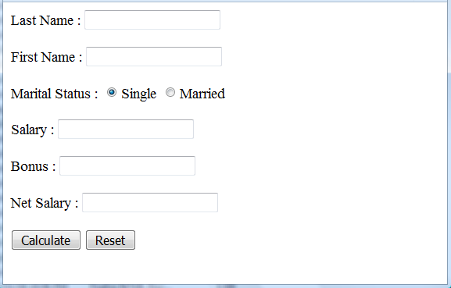

- Write the appropriate HTML5 tags and the appropriate CSS properties to obtain as result the following page: (4 pts)
- The font size in the entire page is 20 pixels.
- The first line is considered as the biggest heading.
- The character type for the first line is the personalized type "palabi.ttf " (use @font-face).
- "Checking Account" is underlined.
- "Top of Page" is a link towards the top of the page.
- The image name is "check.gif" and has the following characteristics:
  - Width : 250 pixels
  - Height : 100 pixels
  - Position : absolute, 150 pixels according to the top of the page and 400 pixels according to the left of the page.
- The message "Check" must be shown instead of the image in case of error.
- Numbers and bullets are lists.
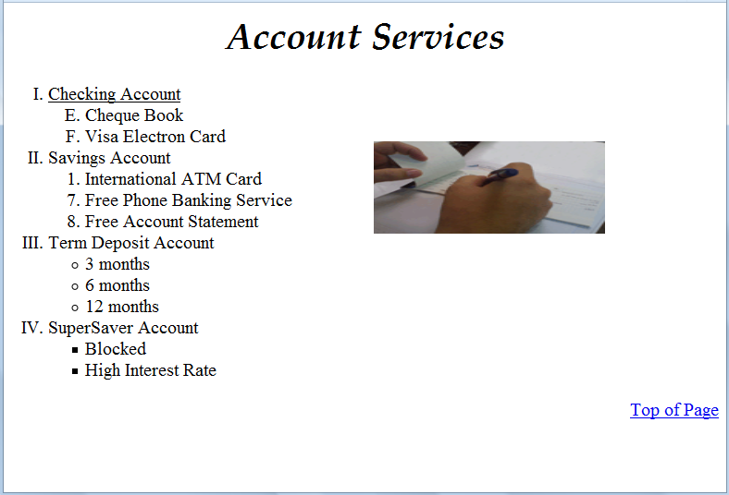
Page1/2

المادة : برمجة ويب Web المعدل: (10)
المستندات المسموح بها : لا شيء المدة : ساعتان

- Write the appropriate HTML5 and JAVASCRIPT tags that creates the 2 following files: (3 pts)

File 1:Index.html  - "Link" is a link towards the file "welcome.html".  - The link color is green and the visited links are blue.  - When the mouse cursor moves over the link (hover), the text link color's becomes red.  For all colors, use hexadecimal code, rgb or rgba code. | File 2:Welcome.html  This page displays the number of visitors.  We must use a counter with (localStorage) that counts the number of visitors.  Each time a user access this page, the counter must be incremented by one and the number of visitors must be displayed.
 | 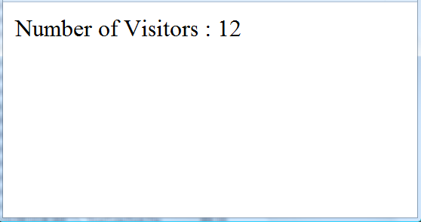

- Write the appropriate HTML5 tags to obtain the following page : (4 pts)
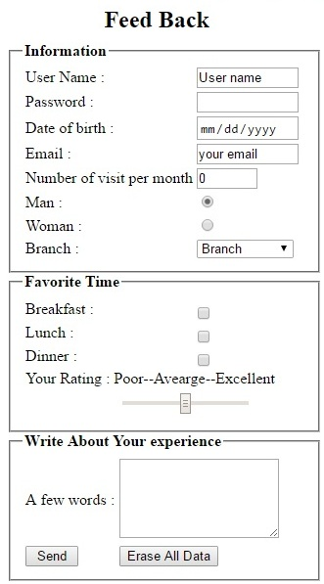 | - User name: Input field, 40 visible characters, and maximum 25 characters.  - Password: Input field, 40 visible characters, and maximum 16 characters, a hidden character "●" must be displayed instead of the characters.  - Indicate the appropriate type for the following fields: Date of birth, Email.  - Number of visit per month: Input field of type number, maximum value: 31, minimum value:0, default value:0.  - Man / Woman: Radio button only one choice is acceptable.  - Branch: Combo box that contains the following values :  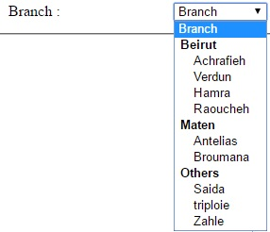  - Breakfast / Lunch / Dinner: Checkbox, many choices are acceptable.  - Your Rating: a scale from 1 to 17, the default value is 9.  - A few words: input fields 5 lines; 20 characters per line.  - A button Send that send all data to the email: info@restaurant.com.  - A button Erase All Data to return the document to the initial state.

- Write the appropriate HTML5 tags and the appropriate CSS properties to obtain as result the following page: (5 pts)
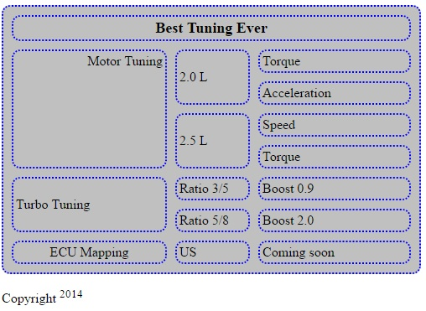 | - The table title is: "Copyright²⁰¹⁴", the title size is: 20 pixels aligned at the left bottom of the table.  - The table has the following characteristics:  Width: 500 pixels; Height: 50 pixels; Space between borders: 10 pixels; Round borders: 10 pixels; background: grey.  - The table and cells border thickness is 2 pixels, the color of the border is blue.  - Keep the table format.  - "Turbo Tuning" is a link towards the web site: "www.turbo_tununig.com"
Page2/2

